Business Sales Performance Analysis

Data Science & Analytics – Task 2

Name : Dosuri Ribaka
CIN ID: FIT/APR26/DS16800

Objective
The objective of this project is to analyze customer retention and churn behavior using customer subscription and service data. The project aims to identify patterns and factors that influence why customers leave a service and what contributes to long-term customer retention.
Through data cleaning, exploratory analysis, and visualization, the project examines important business factors such as contract types, monthly charges, payment methods, internet services, and customer demographics. The analysis helps in understanding customer behavior, identifying high-risk customer segments, and evaluating retention trends.
The project is designed to provide business-focused insights that can support data-driven decision-making for subscription-based businesses and SaaS companies. Based on the analysis, practical recommendations are provided to help improve customer satisfaction, reduce churn rates, strengthen customer retention strategies, and support overall business growth.

Tools Used
• Python : Used for data analysis, cleaning, and customer churn analysis.
• Pandas : Used for handling, organizing, and analyzing dataset tables.
• Matplotlib : Used for creating graphs and visualizations.
• Seaborn : Used for advanced statistical charts and better data visualization.
• Jupyter Notebook (Anaconda) : Used as the development environment to write and execute Python code.

Dataset Description
The dataset used in this project contains customer subscription and service-related information from a telecom company. It includes details about customer demographics, account information, subscription services, payment methods, monthly charges, total charges, and customer churn status.
The dataset consists of 7043 customer records and 21 columns. Each row represents an individual customer and their service usage details. The data is used to analyze customer retention patterns, identify churn behavior, and understand the factors influencing customer satisfaction and loyalty.
Important attributes in the dataset include:
- Customer demographics (gender, senior citizen status, partner, dependents)
- Subscription details (internet service, phone service, contract type)
- Billing information (monthly charges, total charges, payment methods)
- Customer tenure and churn status
This dataset helps perform retention analysis and supports business decision-making related to customer engagement and churn reduction strategies.

Data Cleaning & Preparation
Before performing the analysis, the dataset was cleaned and prepared to ensure accurate results and consistency.
The following data cleaning steps were performed:
- Checked the dataset structure, column names, and data types using Python.
- Identified and verified missing or null values in the dataset.
- Converted the TotalCharges column from object datatype to numeric format for proper analysis.
- Removed rows containing null values to maintain data quality.
- Verified that all important columns were correctly formatted and ready for analysis.
- Ensured the dataset was organized and consistent before visualization and churn analysis.

Customer Churn Overview

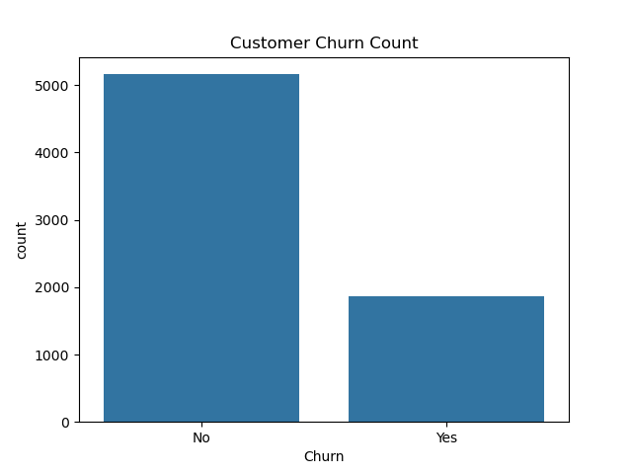

- The graph shows that the number of retained customers is higher than the number of customers who have churned. However, a significant number of customers have left the service, indicating the presence of customer retention challenges.
- The analysis suggests that while the company maintains a strong customer base, customer churn still affects overall business growth and revenue stability.
- Reducing customer churn can help improve long-term customer retention, increase profitability, and strengthen customer satisfaction.

Contract Type Analysis

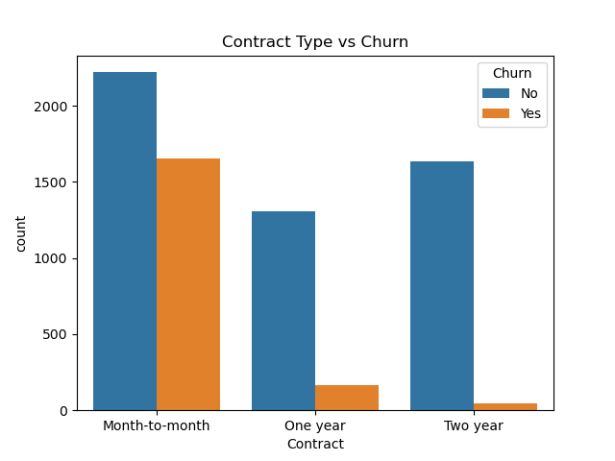

- The graph shows that customers with month-to-month contracts have a higher churn rate compared to customers with one-year or two-year contracts.
- Customers with long-term contracts are more likely to stay with the company, while short-term contract customers are more likely to discontinue the service.
- Encouraging customers to choose long-term contracts through discounts or benefits may help improve customer retention and reduce churn rates.

Monthly Charges Analysis

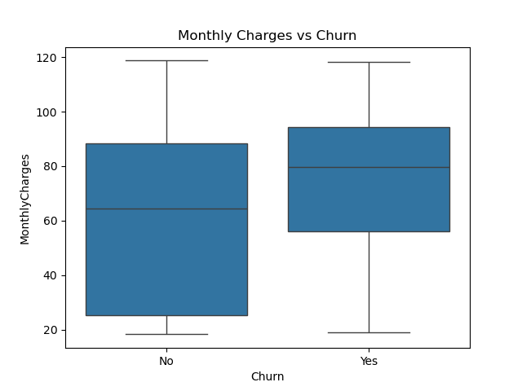

- The graph indicates that customers with higher monthly charges tend to have a higher churn rate compared to customers with lower monthly charges.
- This suggests that pricing may influence customer decisions, and customers may discontinue the service if they feel the cost is too high compared to the value received.
- Reviewing pricing strategies, improving service quality, and offering customer benefits may help reduce churn among high-paying customers.

Payment Method Analysis

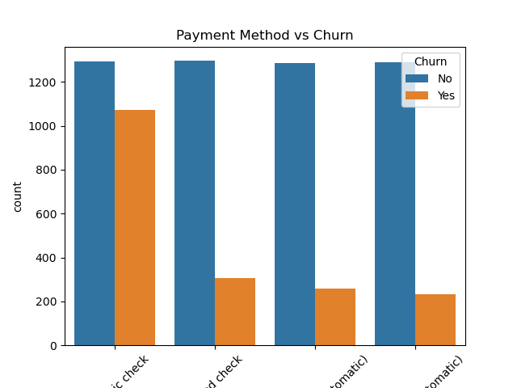

- The graph shows that customer churn varies across different payment methods. Some payment methods have a noticeably higher number of churned customers compared to others.
- This suggests that payment convenience, billing experience, or customer preferences may influence customer retention behavior.
- Improving payment flexibility, simplifying billing processes, and promoting customer-friendly payment options may help reduce churn and improve customer satisfaction.

Internet Service Analysis

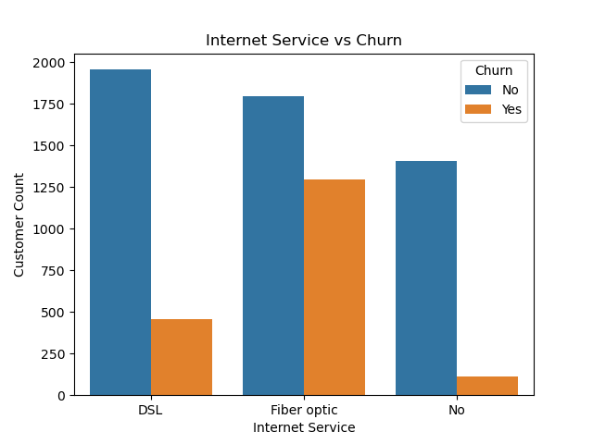

- The graph shows that churn rates differ among customers using different types of internet services. Some internet service categories have a higher number of churned customers compared to others.
- This indicates that customer experience, service quality, or pricing related to internet services may influence customer retention behavior.
- Improving service quality, network reliability, and customer support for high-churn service categories may help reduce customer churn and improve long-term retention.

Key Insights

• Customers with month-to-month contracts show significantly higher churn rates compared to customers with long-term contracts.
• Customers with higher monthly charges are more likely to discontinue the service, indicating that pricing may influence retention.
• Long-term customers demonstrate better retention patterns and lower churn behavior.
• Churn patterns vary across different payment methods, suggesting that billing convenience may affect customer satisfaction.
• Internet service type appears to influence customer retention, as some service categories experience higher churn rates than others. Although the company retains a large portion of customers, customer churn remains a critical business challenge that can impact long-term revenue growth.

Recommendations
• Encourage customers to choose long-term contracts by offering discounts, rewards, or additional benefits.
• Review pricing strategies and provide better value-added services to reduce churn among customers with high monthly charges.
• Improve customer support and service quality to increase customer satisfaction and retention.
• Introduce loyalty programs and personalized offers for high-risk customers to strengthen customer engagement.
• Simplify billing and provide flexible payment options to improve the customer payment experience.
• Monitor customer behavior regularly to identify early signs of churn and take preventive actions. Focus on improving internet service reliability and customer experience in service categories with higher churn rates.

Conclusion
This project focused on analyzing customer retention and churn behavior using telecom customer data. Through data cleaning, exploratory analysis, and visualization, important patterns related to customer churn were identified. The analysis highlighted how factors such as contract type, monthly charges, payment methods, and internet services influence customer retention and customer satisfaction.
The results show that customers with short-term contracts and higher monthly charges are more likely to churn, while long-term customers demonstrate stronger retention behavior. The study also revealed that service-related factors and payment methods can impact customer decisions and overall engagement with the company.
By understanding these customer behavior patterns, businesses can make more informed and data-driven decisions to improve customer retention strategies. Implementing customer-focused improvements such as better pricing strategies, loyalty programs, enhanced service quality, and flexible subscription plans can help reduce churn and improve long-term business growth.
Overall, this project demonstrates how data analytics can be used to identify business challenges, generate meaningful insights, and support strategic decision-making in subscription-based and customer-centric industries.

